**CONCEPTUAL DIAGRAM**

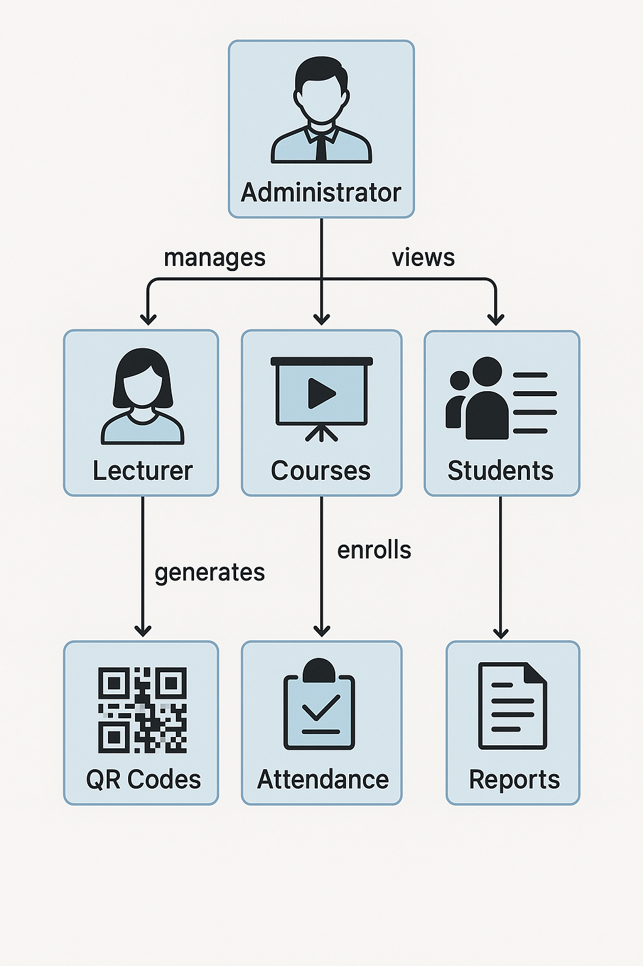

**Scenario:**

* **Lecturer John logs in on a registered device.**
* **He generates a QR Code for his class "IT101" at 9:00 AM.**
* **Student Maria scans the code using her mobile app upon entering the room.**
* **The system verifies her ID and location, and records her as present in the Attendance database.**
* **Administrator Ana later accesses reports showing Maria’s attendance history for auditing.**